Chapter 19, Solution 41.

For the g parameters
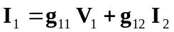 (1)
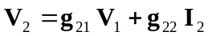 (2)

But 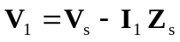 and
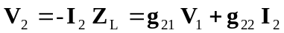
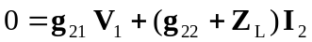
or 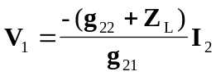

Substituting this into (1),
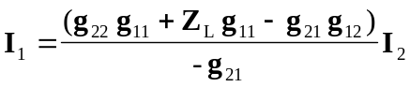
or 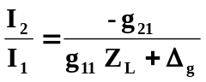

Also, 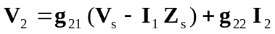
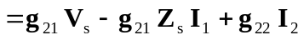
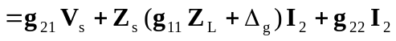

But 